Case Study 52: Hackathon Team Formation and Ranking
1. Problem Statement
Validate hackathon team sizes, calculate team totals from multiple rounds and rank teams. Resolve ties using the highest final-round score.
2. Objectives
Validate that each team has between 2 and 4 members.
Calculate total score across three rounds.
Rank valid teams and resolve ties consistently.
Identify invalid team entries.
3. Assumptions
Each team must contain 2–4 members.
There are three rounds, each scored out of 100.
Ranking uses total score, then Round 3 score, then team name alphabetically.
4. Algorithm
Store each team's members and round scores.
Check team size.
Reject invalid teams.
Calculate total score for each valid team.
Sort by total, final-round score and team name.
Display the final ranking.
5. Flowchart
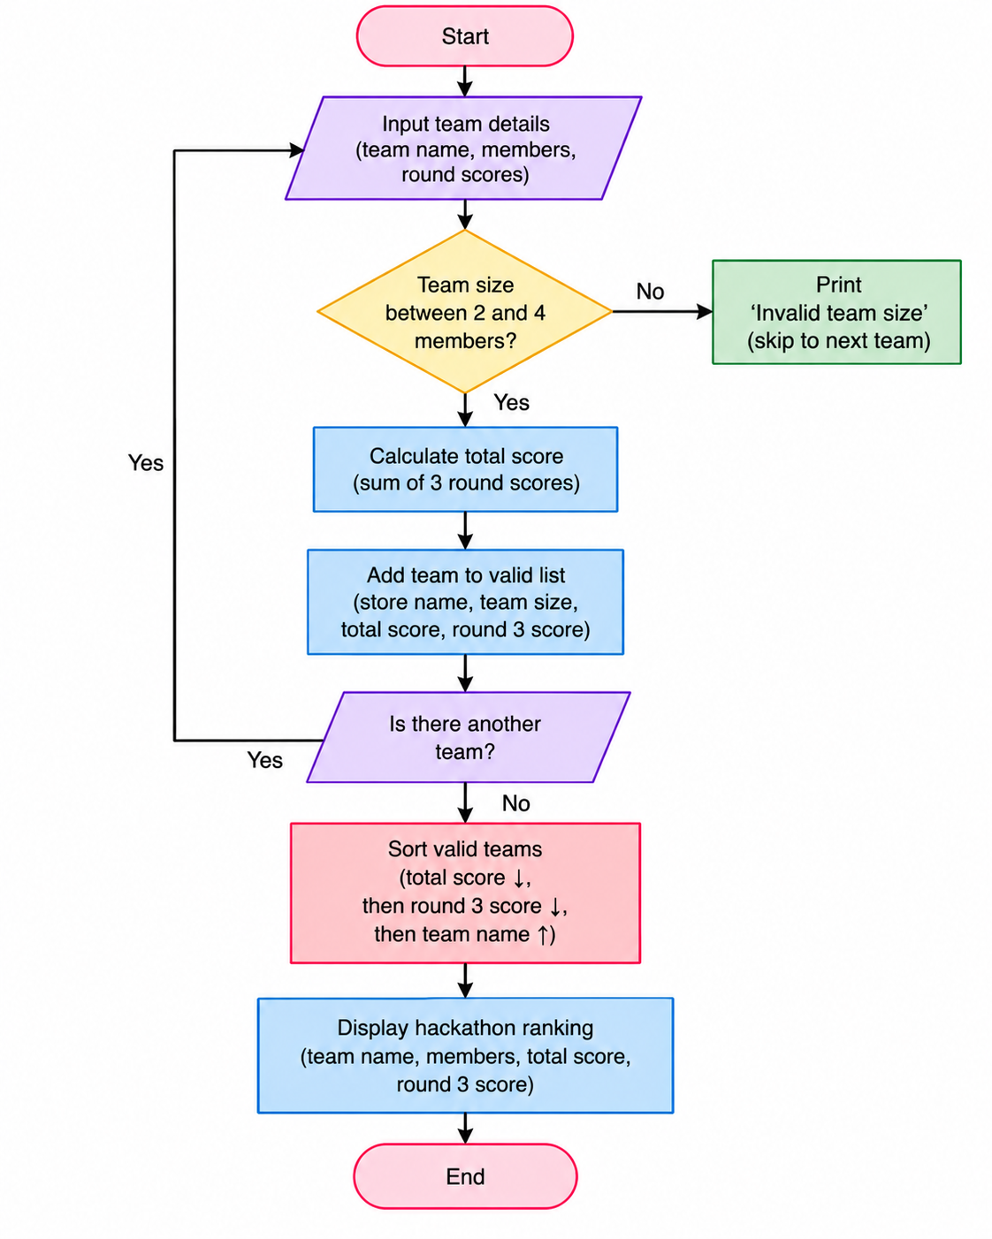
6. Pseudocode
START
Store each team's members and round scores.
Check team size.
Reject invalid teams.
Calculate total score for each valid team.
Sort by total, final-round score and team name.
Display the final ranking.
Display result
7. Test Cases
Input / Record | Expected Result
CodeStars | Valid; total 265
SoloCoder | Rejected; only one member
Debuggers | Rejected; five members
8.Output Screenshot
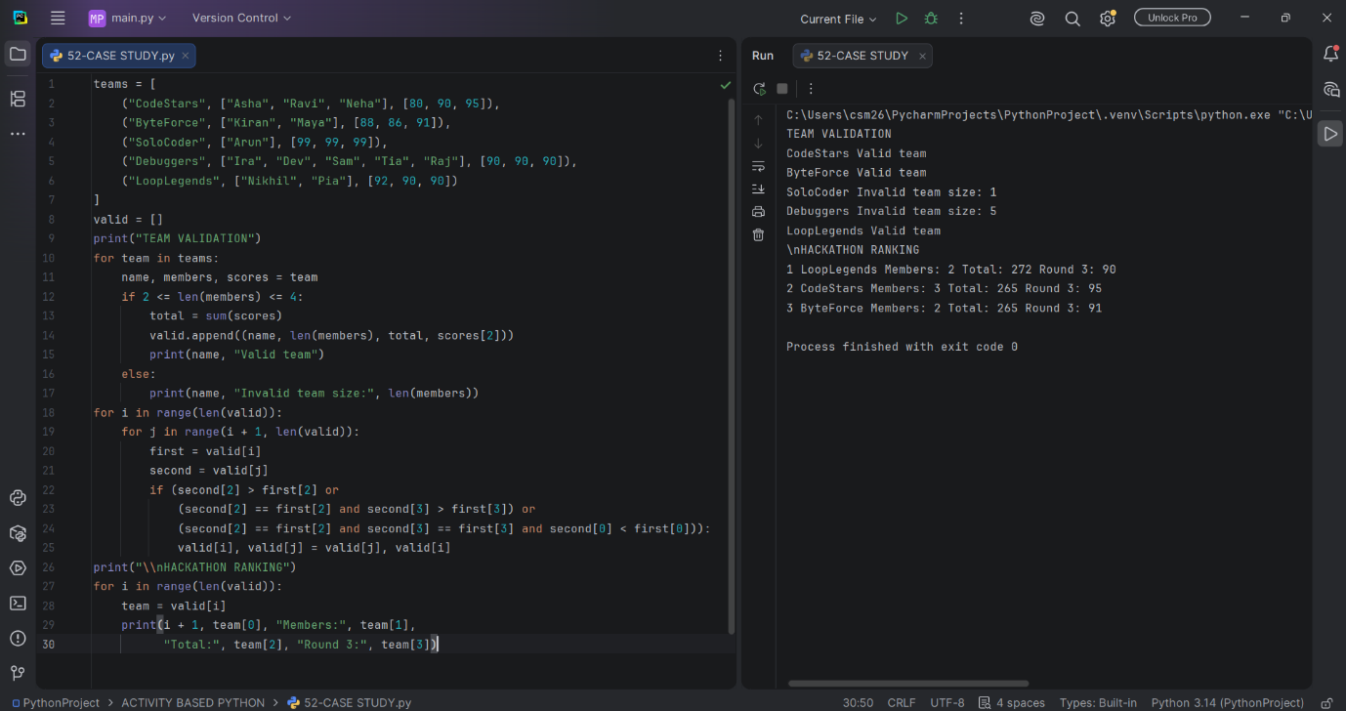
9. Conclusion
The program validates team composition, calculates scores and ranks only valid teams.

